**6.razred**

**Nastavna tema: Zeleno i zdravo /Healthy and green**

**Nastavna jedinica: Healthy Earth**

**Vrsta nastavnog sata:usvajanje novog nastavnog sadržaja**

**UVOD:**

Odigraju Quiz(<https://quizizz.com/embed/quiz/638041975d7495001ecbca3f>

Zatim se ponovo pokrene kviz i zapišu točne rečenice (barem 7) u bilježnice.

**USVAJANJE NOVOG NASTAVNOG SADRŽAJA:**

Nakon toga, prepišu riječi iz 1. zadataka i prevedu ih. (Udžbenik Footsteps 2)

Naslov :

**Healthy Earth**

global warming-globalno zatopljenje

rainforests-kišne šume, prašume

pollution-zagađenje

environment- okoliš

Riješe 1. zadatak u udžbeniku.

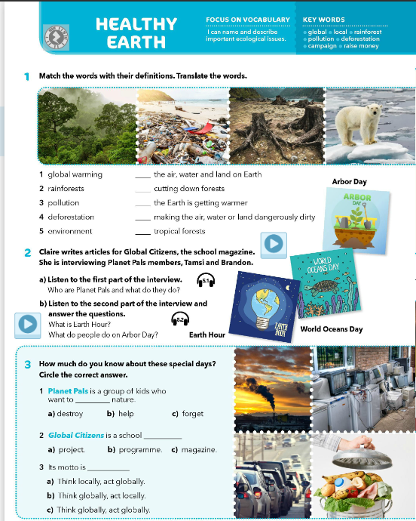

Učenici rade 2. zadatak. Pročitaju naglas što se traži u 2. zadatku.

Učitelj pušta **zvučni zapis**. Dva puta ili tri ako je potrebno.

Svoje odgovore piše u bilježnicu.

**PONAVLJANJE I VJEŽBANJE**

Matching the words and their paraphrases.

Students are given cards which have paraphrases or just a word. Students have to mingle and find the student who has a matching card:

• **Ecology**: The study of how living things interact with each other and their environment.

• **Habitat**: The natural home or environment where a plant or animal lives.

• **Species**: A group of similar living organisms that can breed and produce offspring.

• **Endangered**: At risk of becoming extinct; when a species has very few members left alive.

• **Conservation**: The protection and careful management of natural resources and the environment.

• **Pollution**: Harmful substances that contaminate the environment, like air, water, or soil.

• **Ecosystem**: A community of living things, along with their environment, interacting as a system.

• **Biodiversity**: The variety of different species of plants and animals in a particular place.

• **Climate**: The usual weather conditions in a particular area over a long period of time.

• **Preservation**: Keeping something in its original or existing state; protecting it from harm or decay.

**Ponavljanje uz digitalnu križaljku:**

<https://learningapps.org/display?v=pbr9j4yy524>